Chapter 16:-RAID (Redundant Array of InExpensive Disks) & Logical Volume Manager

History of RAID
The term RAID was coined in 1987 by David Patterson, Randy Katz and Garth A. Gibson. In their 1988 technical report, "A Case for Redundant Arrays of Inexpensive Disks (RAID)," the three argued that an array of inexpensive drives could beat the performance of the top disk drives of the time. By utilizing redundancy, a RAID array could be more reliable than any one disk drive.
While this report was the first to put a name to the concept, the use of redundant disks was already being discussed by others. Geac Computer Corp.'s Gus German and Ted Grunau first referred to this idea as MF-100. IBM's Norman Ken Ouchi filed a patent in 1977 for the technology, which was later named RAID 4. In 1983, Digital Equipment Corp. shipped the drives that would become RAID 1, and in 1986, another IBM patent was filed for what would become RAID 5. Patterson, Katz and Gibson also looked at what was being done by companies such as Tandem Computers, Thinking Machines and Maxstor to define their RAID taxonomies.
While the levels of RAID listed in the 1988 report essentially put names to technologies that were already in use, creating common terminology for the concept helped stimulate the data storage market to develop more RAID array products.
According to Katz, the term inexpensive in the acronym was soon replaced with independent by industry vendors due to the implications of low costs.

How RAID works
RAID works by placing data on multiple disks and allowing input/output (I/O) operations to overlap in a balanced way, improving performance. Because the use of multiple disks increases the mean time between failures (MTBF), storing data redundantly also increases fault tolerance.
RAID arrays appear to the operating system (OS) as a single logical hard disk. RAID employs the techniques of disk mirroring or disk striping. Mirroring copies identical data onto more than one drive. Striping partitions each drive's storage space into units ranging from a sector (512 bytes) up to several megabytes. The stripes of all the disks are interleaved and addressed in order.

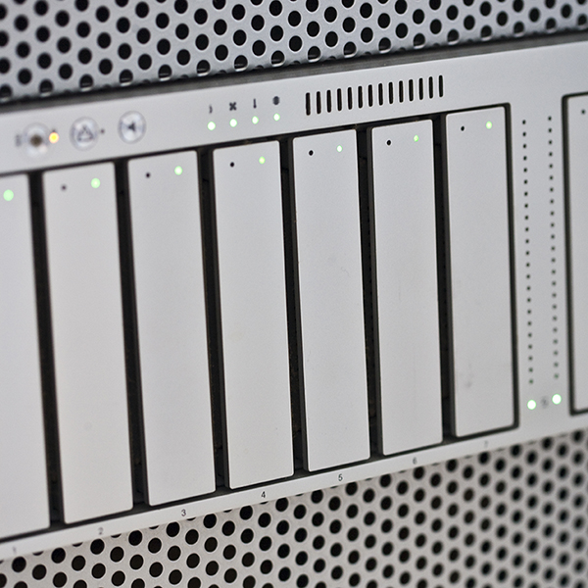
Image of a five-tray RAID hard drive
In a single-user system where large records, such as medical or other scientific images, are stored, the stripes are typically set up to be small (perhaps 512 bytes) so that a single record spans all the disks and can be accessed quickly by reading all the disks at the same time.
In a multiuser system, better performance requires that you establish a stripe wide enough to hold the typical or maximum size record. This allows overlapped disk I/O across drives.
Disk mirroring and disk striping can be combined on a RAID array. Mirroring and striping are used together in RAID 01 and RAID 10.

RAID controller
A RAID controller can be used as a level of abstraction between the OS and the physical disks, presenting groups of disks as logical units. Using a RAID controller can improve performance and help protect data in case of a crash.
A RAID controller can be used in both hardware- and software-based RAID arrays. In a hardware-based RAID product, a physical controller manages the array. When in the form of a Peripheral Component Interconnect or PCI Express card, the controller can be designed to support drive formats such as SATA and SCSI. A physical RAID controller can also be part of the motherboard.
With software-based RAID, the controller uses the resources of the hardware system. While it performs the same functions as a hardware-based RAID controller, software-based RAID controllers may not enable as much of a performance boost.
If a software-based RAID implementation isn't compatible with a system's boot-up process, and hardware-based RAID controllers are too costly, firmware- or driver-based, RAID is another implementation option.
A firmware-based RAID controller chip is located on the motherboard, and all operations are performed by the CPU, similar to software-based RAID. However, with firmware, the RAID system is only implemented at the beginning of the boot process. Once the OS has loaded, the controller driver takes over RAID functionality. A firmware RAID controller isn't as pricy as a hardware option, but puts more strain on the computer's CPU. Firmware-based RAID is also called hardware-assisted software RAID, hybrid model RAID and fake RAID.

RAID levels
In the 1988 paper that coined the term and cemented the concept, the authors distinguished six levels of RAID, 0 through 5. This numbered system allowed them to differentiate the versions and how they used redundancy and spread data across the array. The number of levels has since expanded and has been broken into three categories: standard, nested and nonstandard RAID levels.

Standard RAID levels
RAID 0: This configuration has striping, but no redundancy of data. It offers the best performance, but no fault tolerance.
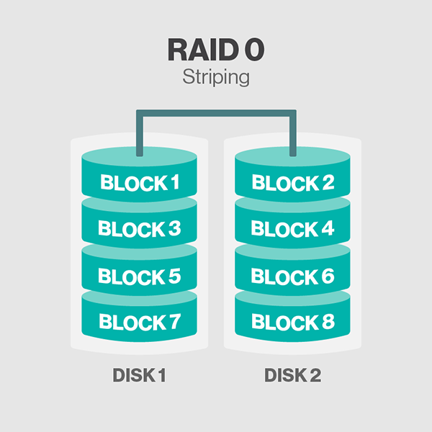

RAID 1: Also known as disk mirroring, this configuration consists of at least two drives that duplicate the storage of data. There is no striping. Read performance is improved since either disk can be read at the same time. Write performance is the same as for single disk storage.
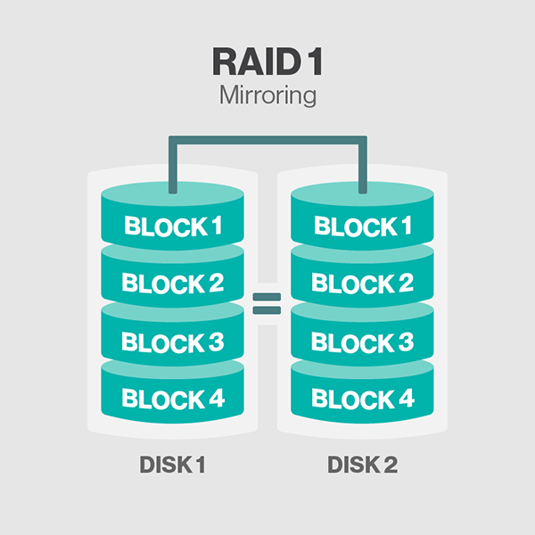

RAID 2: This configuration uses striping across disks, with some disks storing error checking and correcting (ECC) information. It has no advantage over RAID 3 and is no longer used.

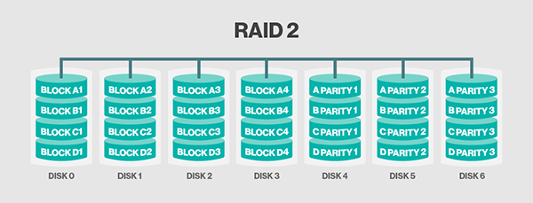

RAID 3: This technique uses striping and dedicates one drive to storing parity information. The embedded ECC information is used to detect errors. Data recovery is accomplished by calculating the exclusive OR (XOR) of the information recorded on the other drives. Since an I/O operation addresses all the drives at the same time, RAID 3 cannot overlap I/O. For this reason, RAID 3 is best for single-user systems with long record applications.

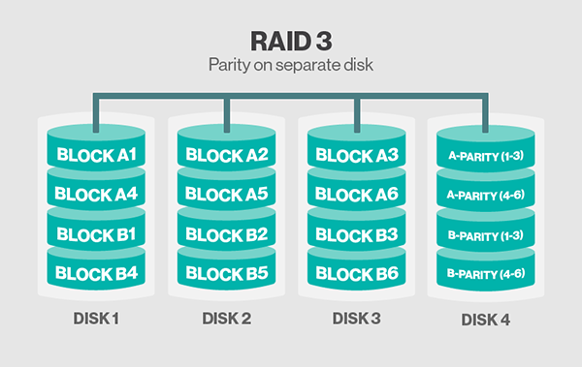

RAID 4: This level uses large stripes, which means you can read records from any single drive. This allows you to use overlapped I/O for read operations. Since all write operations have to update the parity drive, no I/O overlapping is possible. RAID 4 offers no advantage over RAID 5.

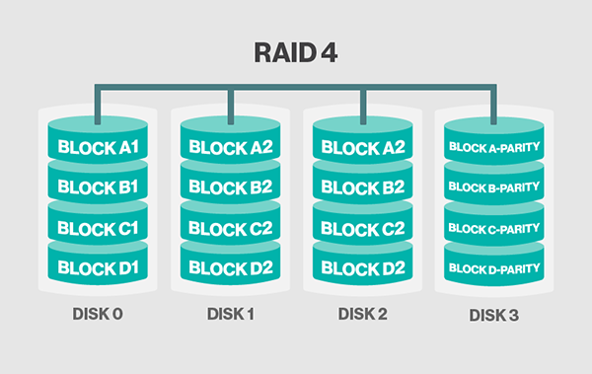

RAID 5: This level is based on block-level striping with parity. The parity information is striped across each drive, allowing the array to function even if one drive were to fail. The array's architecture allows read and write operations to span multiple drives. This results in performance that is usually better than that of a single drive, but not as high as that of a RAID 0 array. RAID 5 requires at least three disks, but it is often recommended to use at least five disks for performance reasons.
RAID 5 arrays are generally considered to be a poor choice for use on write-intensive systems because of the performance impact associated with writing parity information. When a disk does fail, it can take a long time to rebuild a RAID 5 array. Performance is usually degraded during the rebuild time, and the array is vulnerable to an additional disk failure until the rebuild is complete.

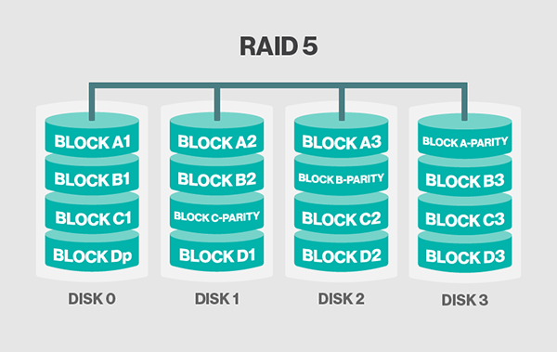

RAID 6: This technique is similar to RAID 5, but includes a second parity scheme that is distributed across the drives in the array. The use of additional parity allows the array to continue to function even if two disks fail simultaneously. However, this extra protection comes at a cost. RAID 6 arrays have a higher cost per gigabyte (GB) and often have slower write performance than RAID 5 arrays.
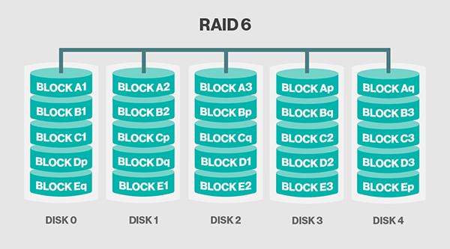

Nested RAID levels
Some RAID levels are referred to as nested RAID because they are based on a combination of RAID levels. Here are some examples of nested RAID levels.
RAID 10 (RAID 1+0): Combining RAID 1 and RAID 0, this level is often referred to as RAID 10, which offers higher performance than RAID 1, but at a much higher cost. In RAID 1+0, the data is mirrored and the mirrors are striped.

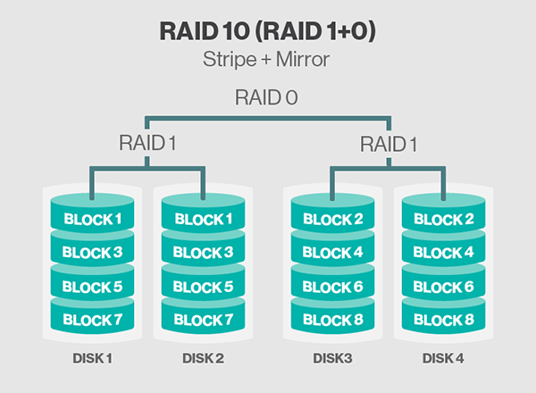
RAID 01 (RAID 0+1): RAID 0+1 is similar to RAID 1+0, except the data organization method is slightly different. Rather than creating a mirror and then striping the mirror, RAID 0+1 creates a stripe set and then mirrors the stripe set.
RAID 03 (RAID 0+3, also known as RAID 53 or RAID 5+3): This level uses striping (in RAID 0 style) for RAID 3's virtual disk blocks. This offers higher performance than RAID 3, but at a much higher cost.
RAID 50 (RAID 5+0): This configuration combines RAID 5 distributed parity with RAID 0 striping to improve RAID 5 performance without reducing data protection.
Nonstandard RAID levels
RAID 7: This RAID level is based on RAID 3 and RAID 4, but adds caching to the mix. It includes a real-time embedded OS as a controller, caching via a high-speed bus and other characteristics of a stand-alone computer. It is a nonstandard, trademarked RAID level owned by the now defunct Storage Computer Corp.
Adaptive RAID: Adaptive RAID lets the RAID controller decide how to store the parity on the disks. It will choose between RAID 3 and RAID 5, depending on which RAID set type will perform better with the type of data being written to the disks.
RAID S (also known as parity RAID): This is an alternate, proprietary method for striped parity RAID from EMC Symmetrix that is no longer in use on current equipment. It appears to be similar to RAID 5 with some performance enhancements, as well as the enhancements that come from having a high-speed disk cache on the disk array.
Linux MD RAID 10: This level, provided by the Linux kernel, supports the creation of nested and nonstandard RAID arrays. Linux software RAID can also support the creation of standard RAID 0, RAID 1, RAID 4, RAID 5 and RAID 6 configurations.
Benefits of RAID
Performance, resiliency and cost are among the major benefits of RAID. By putting multiple hard drives together, RAID can improve on the work of a single hard drive and, depending on how it is configured, can increase computer speed and reliability after a crash.
With RAID 0, files are split up and distributed across drives that work together on the same file. As such, reads and writes can be performed faster than with a single drive. RAID 5 arrays break data into sections, but also devote another drive to parity. This parity drive can see what is working when one nonparity drive fails, and can figure out what was on that failed drive. This function allows RAID to provide increased availability. With mirroring, RAID arrays can have two drives containing the same data, ensuring one will continue to work if the other fails.
Although the term inexpensive was removed from the acronym, RAID can still result in lower costs by using lower-priced disks in large numbers.

Downsides of using RAID
Nested RAID levels are more expensive to implement than traditional RAID levels because they require a greater number of disks. The cost per GB of storage is also higher for nested RAID because so many of the drives are used for redundancy. Nested RAID has become popular in spite of its cost because it helps to overcome some of the reliability problems associated with standard RAID levels.
Initially, all the drives in a RAID array are installed at the same time. This makes the drives the same age and subject to the same operating conditions and amount of wear. But when a drive fails, there is a high probability that another drive in the array will also soon fail.
Some RAID levels (such as RAID 5 and RAID 1) can only sustain a single drive failure, although some RAID 1 implementations consist of multiple mirrors, and can therefore sustain multiple failures. The problem is that the RAID array and the data it contains are left in a vulnerable state until a failed drive is replaced and the new disk is populated with data. Because drives have much greater capacity now than when RAID was first implemented, it takes a lot longer to rebuild failed drives. Longer rebuild times increase the chance that a second drive will fail before the first drive is rebuilt.
Even if a second disk failure does not occur while the failed disk is being replaced, there is a chance the remaining disks may contain bad sectors or unreadable data. These types of conditions may make it impossible to fully rebuild the array.
Nested RAID levels address these problems by providing a greater degree of redundancy, greatly decreasing the chances of an array-level failure due to simultaneous disk failures.
The future of RAID
RAID is not quite dead, but many analysts say the technology has become obsolete in recent years. Alternatives such as erasure coding offer better data protection (albeit at a higher price), and have been developed with the intention of addressing the weaknesses of RAID. As drive capacity increases, so does the chance for error with a RAID array, and capacities are consistently increasing.

How to Extend/Reduce LVM’s (Logical Volume Management) in Linux – Part II
Previously we have seen how to create a flexible disk storage using LVM. Here, we are going to see how to extend volume group, extend and reduce a logical volume. Here we can reduce or extend the partitions in Logical volume management (LVM) also called as flexible volume file-system.
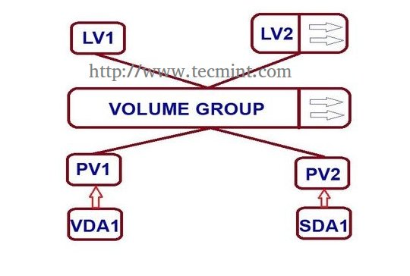
Extend/Reduce LVMs in Linux

Requirements
- Create Flexible Disk Storage with LVM – Part I

When do we need to reduce volume?
May be we need to create a separate partition for any other use or we need to expand the size of any low space partition, if so we can reduce the large size partition and we can expand the low space partition very easily by the following simple easy steps.

My Server Setup – Requirements
- Operating System – CentOS 6.5 with LVM Installation
- Server IP – 192.168.0.200

How to Extend Volume Group and Reduce Logical Volume

Logical Volume Extending
Currently, we have One PV, VG and 2 LV. Let’s list them one by one using following commands.
# pvs
# vgs
# lvs

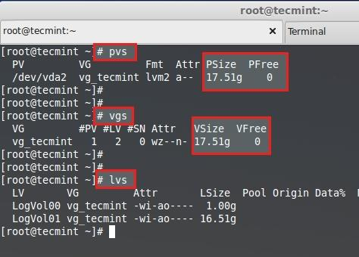

Logical Volume Extending
There are no free space available in Physical Volume and Volume group. So, now we can’t extend the lvm size, for extending we need to add one physical volume (PV), and then we have to extend the volume group by extending the vg. We will get enough space to extend the Logical volume size. So first we are going to add one physical volume.
For adding a new PV we have to use fdisk to create the LVM partition.
# fdisk -cu /dev/sda
- To Create new partition Press n.
- Choose primary partition use p.
- Choose which number of partition to be selected to create the primary partition.
- Press 1 if any other disk available.
- Change the type using t.
- Type 8e to change the partition type to Linux LVM.
- Use p to print the create partition ( here we have not used the option).
- Press w to write the changes.
Restart the system once completed.
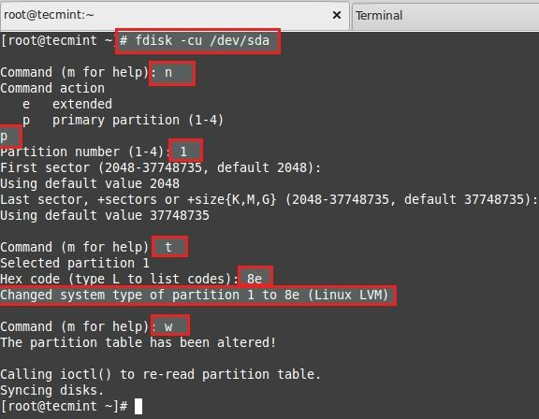

Create LVM Partition
List and check the partition we have created using fdisk.
# fdisk -l /dev/sda

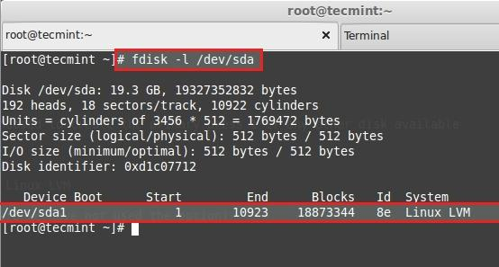
Verify LVM Partition
Next, create new PV (Physical Volume) using following command.
# pvcreate /dev/sda1
Verify the pv using below command.
# pvs

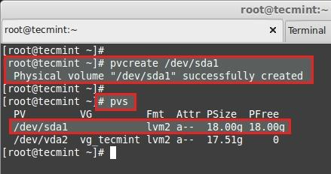
Create Physical Volume

Extending Volume Group
Add this pv to vg_tecmint vg to extend the size of a volume group to get more space for expanding lv.
# vgextend vg_tecmint /dev/sda1
Let us check the size of a Volume Group now using.
# vgs
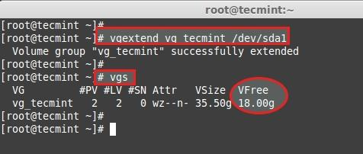
Extend Volume Group
We can even see which PV are used to create particular Volume group using.
# pvscan

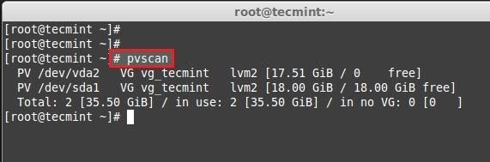

Check Volume Group
Here, we can see which Volume groups are under Which Physical Volumes. We have just added one pv and its totally free. Let us see the size of each logical volume we have currently before expanding it.
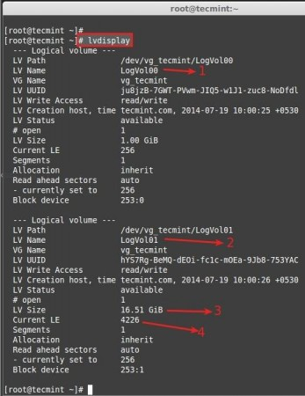
Check All Logical Volume
- LogVol00 defined for Swap.
- LogVol01 defined for /.
- Now we have 16.50 GB size for / (root).
- Currently there are 4226 Physical Extend (PE) available.
Now we are going to expand the / partition LogVol01. After expanding we can list out the size as above for confirmation. We can extend using GB or PE as I have explained it in LVM PART-I, here I’m using PE to extend.
For getting the available Physical Extend size run.
# vgdisplay
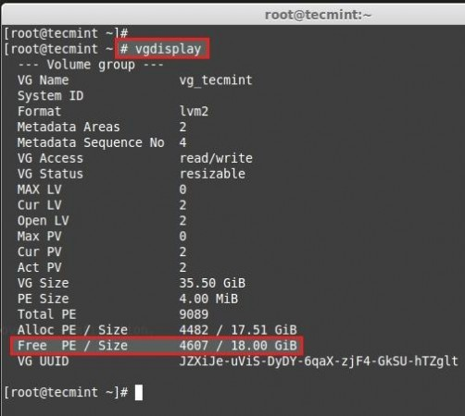

Check Available Physical Size
There are 4607 free PE available = 18GB Free space available. So we can expand our logical volume up-to 18GB more. Let us use the PE size to extend.
# lvextend -l +4607 /dev/vg_tecmint/LogVol01
Use + to add the more space. After Extending, we need to re-size the file-system using.
# resize2fs /dev/vg_tecmint/LogVol01

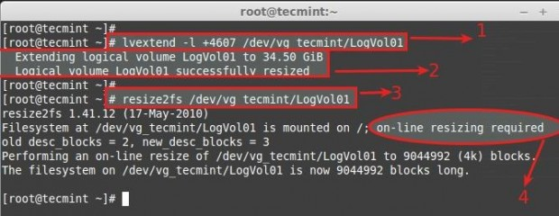

Expand Logical Volume
- Command used to extend the logical volume using Physical extends.
- Here we can see it is extended to 34GB from 16.51GB.
- Re-size the file system, If the file-system is mounted and currently under use.
- For extending Logical volumes we don’t need to unmount the file-system.
Now let’s see the size of re-sized logical volume using.
# lvdisplay

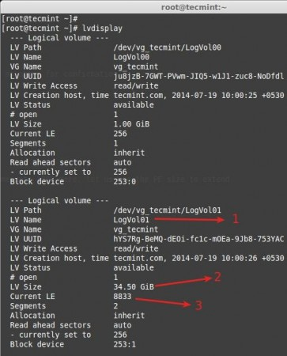

Resize Logical Volume
- LogVol01 defined for / extended volume.
- After extending there is 34.50GB from 16.50GB.
- Current extends, Before extending there was 4226, we have added 4607 extends to expand so totally there are 8833.
Now if we check the vg available Free PE it will be 0.
# vgdisplay
See the result of extending.
# pvs
# vgs
# lvs
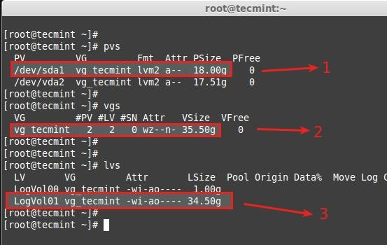

Verify Resize Partition
- New Physical Volume added.
- Volume group vg_tecmint extended from 17.51GB to 35.50GB.
- Logical volume LogVol01 extended from 16.51GB to 34.50GB.
Here we have completed the process of extending volume group and logical volumes. Let us move towards some interesting part in Logical volume management.

Reducing Logical Volume (LVM)
Here we are going to see how to reduce the Logical Volumes. Everyone say its critical and may end up with disaster while we reduce the lvm. Reducing lvm is really interesting than any other part in Logical volume management.
- Before starting, it is always good to backup the data, so that it will not be a headache if something goes wrong.
- To Reduce a logical volume there are 5 steps needed to be done very carefully.
- While extending a volume we can extend it while the volume under mount status (online), but for reduce we must need to unmount the file system before reducing.
Let’s see what are the 5 steps below.
- unmount the file system for reducing.
- Check the file system after unmount.
- Reduce the file system.
- Reduce the Logical Volume size than Current size.
- Recheck the file system for error.
- Remount the file-system back to stage.
For demonstration, I have created separate volume group and logical volume. Here, I’m going to reduce the logical volume tecmint_reduce_test. Now its 18GB in size. We need to reduce it to 10GB without data-loss. That means we need to reduce 8GB out of 18GB. Already there is 4GB data in the volume.
18GB ---> 10GB
While reducing size, we need to reduce only 8GB so it will roundup to 10GB after the reduce.
# lvs

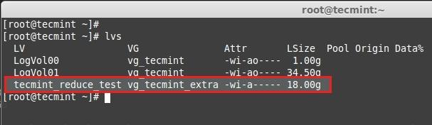
Reduce Logical Volume
Here we can see the file-system information.
# df –h

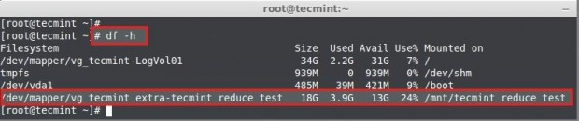

Check File System Size
- The size of the Volume is 18GB.
- Already it used upto 3.9GB.
- Available Space is 13GB.
First unmount the mount point.
# umount -v /mnt/tecmint_reduce_test/

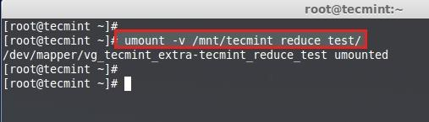

Unmount Parition
Then check for the file-system error using following command.
# e2fsck -ff /dev/vg_tecmint_extra/tecmint_reduce_test
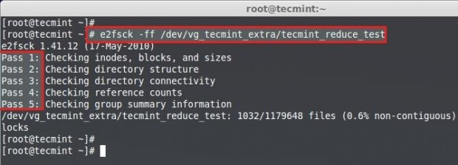
Scan Parition for Errors
Note: Must pass in every 5 steps of file-system check if not there might be some issue with your file-system.
Next, reduce the file-system.
# resize2fs /dev/vg_tecmint_extra/tecmint_reduce_test 10GB

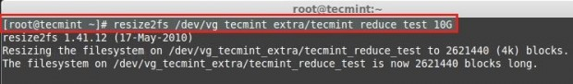
Reduce File System
Reduce the Logical volume using GB size.
# lvreduce -L -8G /dev/vg_tecmint_extra/tecmint_reduce_test

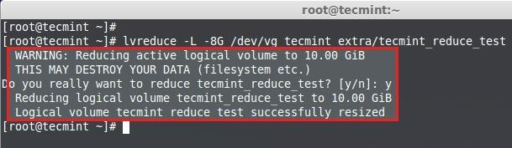

Reduce Logical Partition
To Reduce Logical volume using PE Size we need to Know the size of default PE size and total PE size of a Volume Group to put a small calculation for accurate Reduce size.
# lvdisplay vg_tecmint_extra
Here we need to do a little calculation to get the PE size of 10GB using bc command.
1024MB x 10GB = 10240MB or 10GB
10240MB / 4PE = 2048PE
Press CRTL+D to exit from BC.
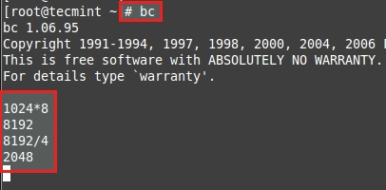

Calculate PE Size
Reduce the size using PE.
# lvreduce -l -2048 /dev/vg_tecmint_extra/tecmint_reduce_test

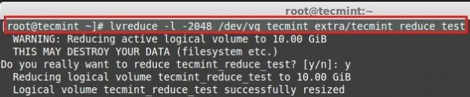
Reduce Size Using PE
Re-size the file-system back, In this step if there is any error that means we have messed-up our file-system.
# resize2fs /dev/vg_tecmint_extra/tecmint_reduce_test

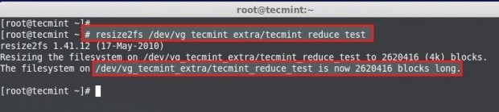
Resize File System
Mount the file-system back to same point.
# mount /dev/vg_tecmint_extra/tecmint_reduce_test /mnt/tecmint_reduce_test/
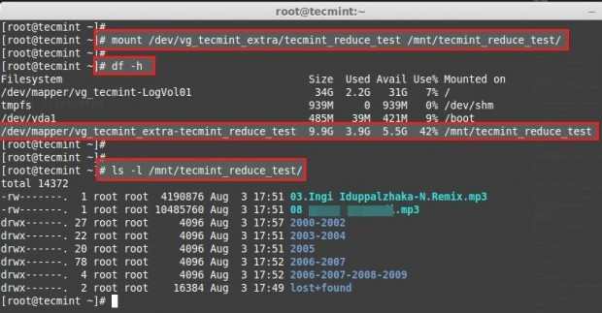

Mount File System
Check the size of partition and files.
# lvdisplay vg_tecmint_extra
Here we can see the final result as the logical volume was reduced to 10GB size.

